ASSESSMENT ASSIGNMENT
Fatima Ahmed
How do the artifacts selected reflect or contradict your own values/beliefs about assessment and evaluation of 21st century learners?
My beliefs about assessment and evaluation are captured in the following quote, “Students are required to demonstrate the skills of assessment (making a judgement), so this skill should be targeted for evaluation and reporting. Assessment is a higher-order thinking skill (HOTS) that needs to be taught to students (or reviewed) to establish validity. Similarly, historical thinking and communication skills will need to be taught or reviewed.” (Drake, 2014, p. 66)
21st century skills are defined in the following excerpt, “Teachers will be more familiar with the higher-order thinking skills (HOTS) that are end goals in most twenty-first-century curriculum…. Renowned curriculum and assessment theorist Susan Brookhart (2004) includes the following in her definition of HOTS:
- Analysis, evaluation and creation
- Logical reasoning
- Judgement and critical thinking
- Problem solving, creativity and creative thinking” (Drake, 2014, p. 37)
Thus, the selected artefacts reflect my beliefs because they have, at their core, the higher order thinking skills.
Explicitly discuss the difference between assessment and evaluation and how they are used in classrooms.
The following quote illustrates the difference between evaluation and assessment, “During the 20th century, assessment was often defined as evaluation and assessment. Evaluation is summative assessment conducted at the end of an instructional period to measure achieved learning. It is also the term used for standardized measures such as large-scale provincial assessments. In comparison, assessment is now considered classroom-based and includes diagnostic and formative feedback during the instructional period to improve learning.” (Drake, 2014, p. 13) Thus, today, we identify three forms of assessment: as, for and of.
A Guide to Effective Instruction in Writing, Kindergarten to Grade 3 (2005, p. 7.3) presents the following chart as it attempts to describe the difference between assessment and evaluation and how they are used in the classrooms.
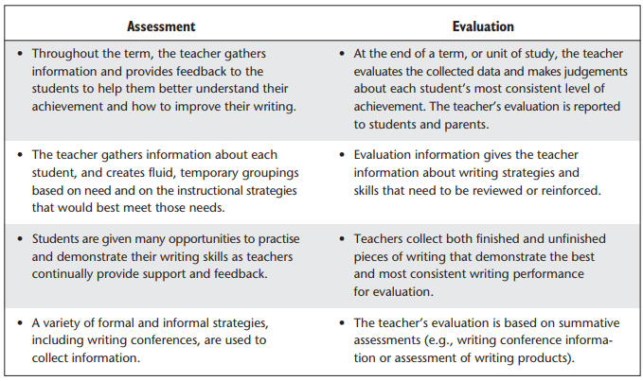
The following chart from Drake (2014, p. 18) summarizes the difference in purpose and timing between the three different forms of assessment:
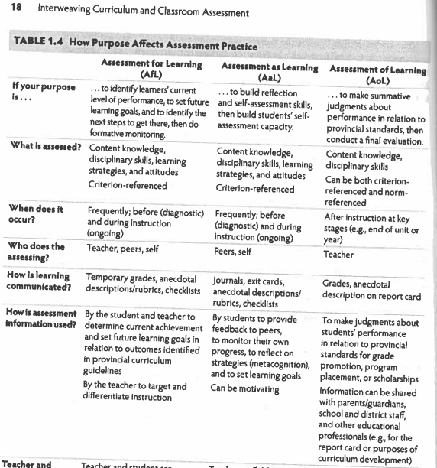

Discuss the role of effective feedback in the assessment loop and the role of students in owning their learning. How does a teacher use assessment “as”, “for” and “of” to foster student ownership of his/her own learning?
Growing Success (2010) mentions on page 6 the seven fundamental principles of assessment and evaluation. They are as follows:
“The Seven Fundamental Principles
To ensure that assessment, evaluation, and reporting are valid and reliable, and that they lead to the improvement of learning for all students, teachers use practices and procedures that:
• are fair, transparent, and equitable for all students;
• support all students, including those with special education needs, those who are learning the language of instruction (English or French), and those who are First Nation, Métis, or Inuit;
• are carefully planned to relate to the curriculum expectations and learning goals and, as much as possible, to the interests, learning styles and preferences, needs, and experiences of all students;
• are communicated clearly to students and parents at the beginning of the school year or course and at other appropriate points throughout the school year or course;
• are ongoing, varied in nature, and administered over a period of time to provide multiple opportunities for students to demonstrate the full range of their learning;
• provide ongoing descriptive feedback that is clear, specific, meaningful, and timely to support improved learning and achievement;
• develop students’ self-assessment skills to enable them to assess their own learning, set specific goals, and plan next steps for their learning.”
Thus, effective feedback and communication is one of the seven fundamental principles of assessment and evaluation.
Some tips on how to use assessment “as”, “for” and “of” to foster student ownership in her own learning are mentioned on page 31 of A Guide to Effective Literacy Instruction - Volume 2: Assessment (2006).

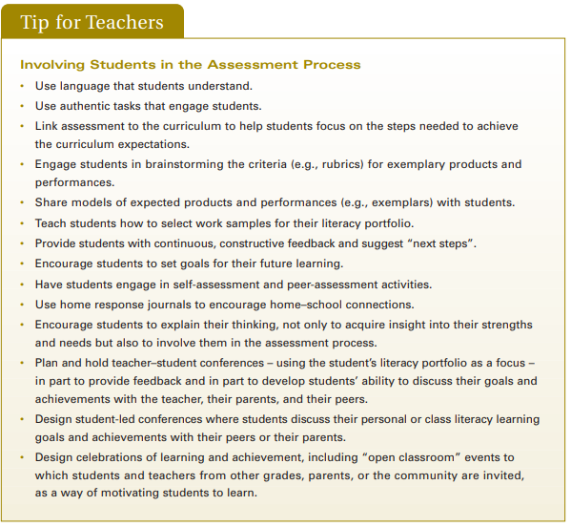
Thus, the role effective feedback plays in the assessment loop and in fostering student ownership of their learning is to encourage student ownership of learning.
Page 32 of A Guide to Effective Literacy Instruction - Volume 2: Assessment (2006) states the following about linking assessment to planning and instruction, thus closing the assessment loop through the help of effective feedback:
“• explicitly teaches the material to be learned, models relevant skills, and provides multiple and varied opportunities for students to practise and demonstrate their newly learned skills and knowledge;
• uses a range of assessment strategies and tools to gather information about how students are learning and to provide explicit, timely, relevant feedback to students about their performance;
• uses assessment data to inform instruction and planning.”
The guide goes on to state that dialogue is an effective way of fostering student ownership for their learning.
“By effectively analysing the data collected from a variety of assessments, teachers determine patterns and trends, areas of strength, and areas that need improvement, and, ultimately, reach an evaluation of each student’s performance. Based on assessment findings, teachers make informed decisions about the instruction, practice, and resources needed to build on students’ individual strengths and to meet students’ individual needs. Finally, teachers need to share the results of assessments with students as soon as possible, offering observations, analyses, and suggestions and inviting students to share their own views and self-assessments. Students need to understand that literacy skills are transferable and useful in all content areas, and that assessment strategies and next steps are relevant in all subject areas. This dialogue models the kind of thinking and collaborative determination of next steps that moves students closer to becoming independent learners. It also encourages students to take ownership of their learning and, ultimately, leads to improved levels of achievement.” (2006, p. 35).
The student roles mentioned for each of Assessment “of”, “as” and “for” learning in table 1.4 state how educators can work collaboratively with students to foster student ownership of learning.
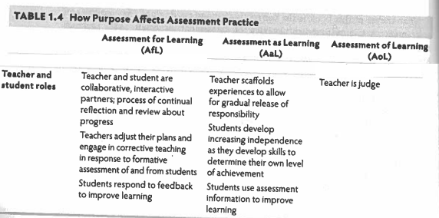
Explain how you might communicate progress to parents and what this would look like.
A Guide to Effective Literacy Instruction - Volume 2: Assessment states on page 32, “Continuous communication is an essential component of literacy assessment in the junior grades. Communication of assessment is reciprocal and cyclical and involves teachers, students, and parents. At all stages, teachers communicate assessment information to students and parents. As well, teachers in the school communicate with one another and with the administration” (2006). I agree and believe that the best way to communicate progress to parents, especially if placed in a Kindergarten class, are daily conversations when the parents come to pick up their children after school. In addition, a practice of sending home classwork and crafts can push towards an Assessment As Learning opportunity even when at home, as the students attempt to explain to their caregivers and parents what it is that they have brought back home.
Further more, I believe report cards are essential to teacher transparency and accountability. Section 6 of Growing Success runs from page 47-68 and speaks about the provincial reporting expectations and best practices. Of special mention are the learning skills and work habits that are assessed at every report card.
“The Elementary Progress Report Card and the elementary and secondary provincial report cards provide a record of the learning skills and work habits demonstrated by students in the following six categories:
• Responsibility
• Organization
• Independent Work
• Collaboration
• Initiative
• Self-Regulation” (2010, p. 55)
What is important to recognize is that these seven learning skills and work habits are different from the higher-order thinking skills (HOTS) identified in the Drake text.
How does planned, purposeful assessment contribute to classroom management?
I sincerely believe that all reasons of undesirable classroom behaviour can be addressed with effective curriculum and assessment planning. Thus, planned purposeful assessment can play the role of indirect classroom management as it provides a safe, predictable environment to students who are aware of how the different forms of assessment is further helping them grow as learners.
In addition, self-assessment by teachers is essential, as is stated in the following quote, “The last step in backward design involves evaluation the effectiveness of your planning through consolidation and reflection during and after implementation. There are various ways to collect the reflective data to accomplish this task, such as ongoing student-teacher learning journals, reflections on daily lesson plans and anecdotal observations of effective instructional strategies, rich performance tasks, assessment tools, blog/web responses and unit artefacts… In the spirit of AfL, it is important to use assessment information to improve one’s learning.” (Drake, 2014, p. 91)
What is your developing philosophy of assessment and how do you envision it occurring in your classroom?
I agree with Cooper when he states “Assessment must be balanced including oral, performance, and written tasks, and be flexible in order to improve learning for all students.” (2007, p. 106) In addition, my developing philosophy of assessment holds, at its core, the presence of peer assessment, self assessment, performance assessment and authentic assessment. I believe performance and authentic assessment are important because these forms of assessment are better representatives of how we perform on-the-job, and because I believe the primary goal of education is to assist students in securing and performing highly in full-time jobs after the students graduate. I believe in peer and self-assessment because “students need to be assessment literate… students need to be taught how to give feedback responsibly… (and because) self-assessment involves several interconnected parts: evaluation, reflection, metacognition and goal setting.” (Drake, 2014, p. 89) Thus, I agree with Earl’s belief that “self-assessment and metacognition are the pinnacle of assessment.” (Drake, 2014, p. 89)
I also like this following chart (Drake, 2014, p. 81) that lists examples of assessment tasks that a teacher can plan for, as they she/he plans the curriculum in their course. I envision using many of these in my classroom.
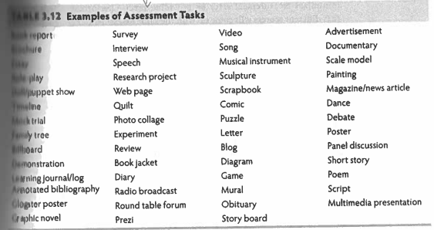
References
Canada, Ministry of Education. (2005). A Guide to Effective Instruction in Writing, Kindergarten to Grade 3. Retrieved January 23, 2019, from http://www.eworkshop.on.ca/edu/resources/guides/Guide_Writing_ K_3.pdf
Canada, Ministry of Education. (2006). A Guide to Effective Literacy Instruction - Volume 2: Assessment (Vol. 2). Retrieved January 23, 2019, from http://www.eworkshop.on.ca/edu/resources/guides/Guide_Lit_456_Vol_2_Assessement.pdf
Canada, Ministry of Education. (2010). Growing Success: Assessment, Evaluation and Reporting in Ontario Schools. First Edition, Covering Grades 1 to 12.
Cooper, D., & Adams, K. (2007). Talk about assessment strategies and tools to improve learning. Toronto, ON: Thomson/Nelson.
Drake, S. M. (2014). Interweaving curriculum and classroom assessment: Engaging the 21st century learner. Don Mills, Ontario: Oxford University Press.

SAMPLE 1: ASSESSMENT AS LEARNING
DANCE STUDIO

OBSERVATIONS
The kids have gathered together for a dance studio. They are in the carpet area and it is the after-lunch period. I see the children try out different dance movies. Later, I see Rocco run in circles, leaping while holding scarves. I see Ms. Washburn ask questions like “Is the music fast or slow?” and “How could you suit your dance to this music?” The children seem a little confused. One or two students attempt to change their moves according to the music. This is how students reflected on their learning. They also tried to name the music they heard by identifying it as fast or slow.
INTERPRETATION:
Being able to pay attention to music and create dance represents developing artistic behaviour. I can notice and name an ability to pay attention to following instructions, an ability to explain their creative expression through dance and words. Developing behaviours noticed were creativity and creative expression. Thus, the dance studio is a good example of assessment “as” learning.
SRWB 7.1: Participate actively in creative movement and other daily physical activities
DLMB 21.1: Express their responses to drama and dance
DLMB 21.3: Express their responses to music by moving, by making connections to their own experiences, or by talking about the musical form
DLMB 21.4: Respond to music from various cultures and communities
DLMB 31.1: Explore different elements of drama
EXTENSIONS/CHALLENGES/NEXT STEPS:
Respond: I would ask students to adopt their dance to the music as we play music of various cultures and communities (S.E. 21.4)
Challenge: I would ask questions similar to Ms. Washburn’s questions, where we ask the students to further describe the relationship between music and dance. I would request the students to watch each other’s dance performance and share how it made them feel (S.E. 21.1.)
Extend: I would ask the students to describe different elements of their dance, such as the rhythm, space and shape (S.E. 31.1). I would ask the student to describe different elements of their music (S.E. 21.3). This extension would continue the assessment AS learning, as students attempt to explain their thinking and creative process to the educator.
PICTURES:
Please see next page

SAMPLE 2: ASSESSMENT AS LEARNING
BOYS WITH CARS

OBSERVATIONS:
Elijah, Trevor and Nathan are playing with the cars-and-roads learning centre. The roads have a number pasted on them and the kids have to put down a matching number of cars. I see the children make siren and driving sounds to indicate that the cars are moving. Trevor puts down a stop sign to indicate that cars can’t pass the stop sign. Elijah, Trevor and Nathan each have chosen cars with the number 5 on them and they address me, the educator, to identify and read the number. Elijah also shows me a car with the numbers 1 and 8 written on them. Thus, they are demonstrating knowledge of numbers and road rules.

ANALYSIS/REFLECTION:
Since they pointed out individual numbers, the children demonstrated mathematical literacy and awareness of individual numbers during this this play-based assessment AS learning. I noticed an ability to recognize numbers, play together and identify opportunities for mathematical connections during free play. The next step for students would be to identify which numbers they do not recognize, so that they can take the responsibility of learning additional numbers.
SRWB 2.5: When Alex D who is crying asks to play, Elijah and Tyler gladly allow him to join the game, thus demonstrating empathy.
DLMB 20.2: The students use, read and represent whole numbers to 10 in a variety of meaningful contexts
Conceptual understanding: “We can use objects, pictures, symbols and/or words to represent numbers and quantities” (p. 216)

EXTENSIONS/CHALLENGES/NEXT STEPS:
Respond: I might ask them to count out 5 cars for me.
Challenge: I might ask them to find more numbers around them.
Extend: I might ask them the difference between 5 and 8 cars.

PICTURES:
See next page

SAMPLE 3: ASSESSMENT AS LEARNING
COUNTING CARS GAME

OBSERVATIONS:
Alex B, Ethan and Thomas are playing the counting cars game with the cars and road resource. The game was setup to teach them counting. The students sometimes recognize the numbers on the road, and counted out the cars matching the number. After, they continued to play with the cars. When asked how main cars they have they would point and tag to count the number of cars present on the road. Thus, this fulfilled the assessment as learning category because they were able to think-aloud as they counted when prompted.

ANALYSIS/REFLECTION:
The next steps were as follows and fell in these categories:
DLMB: Encourage them to continue pointing/tagging
DLMB: Introduce them to numbers they don’t recognize in reading
DLMB: Ask them to tell me how many cars we need to add if we have 7 and want 9 in total
SRWB/PSI # 4.1: encourage them to resolve interpersonal conflict on their own

PICTURES:
No picture available

SAMPLE 4: ASSESSMENT AS LEARNING
BUILDING A TOWER OUT OF BLOCKS
Observations:
As part of Tinker Tuesdays, we assigned partners to each of the children and requested that they take turns as they collaboratively build a tower together with the materials provided. I was assigned as the partner for VW. When VW approached the blocks, she did not understand the concept of taking turns Slowly, after modelling taking turns, she began to understand the concept partially – instead of placing the blocks directly onto the tower, she would hand over the blocks to me in order for me to place them into the tower.
Analysis/Reflection:
VW was able to mimic expressions of happiness and unhappiness (SE 6.5). For instance, she would clap when the tower would remain standing upon addition of new blocks and vocalize a sound that sounded like “Oh no!” when the tower fell apart. When the blocks fell, she would go back to building the tower and demonstrated a sense that certain blocks could better support the structure. For instance, if choosing a small block, she would use multiple of them to cover the surface area of the preceding blocks. For somebody with a suspected ASD diagnoses, this play based inquiry enabled us to practice assessment as learning as much as possible with a student who is largely non-verbal.
The next steps for VW would be to further experiment with vocal cues and to internalize the conceptual understanding that communication includes non-verbal behaviours and gesturing. We can experiment with words to achieve intended effects. (p. 182)
Extension/Challenges/Next Steps:
Encourage Vanish to use more verbal and non-verbal cues to express happiness and unhappiness.
Pictures:

SAMPLE 1: ASSESSMENT FOR LEARNING
ARIA AND THE COUNTING GAME
OBSERVATIONS:
During week 1 of our placement, I conducted a math assessment at the beginning of the placement, as a diagnostic assessment or assessment FOR learning. The purpose of this assessment was to identify Aria’s starting learning point. Later in week 4, I conducted this same math assessment with Aria as to inform me how much Aria had learnt since the beginning of my placement. Thus, this facilitated the assessment “OF” learning requirement. The assessment tool used was sourced from "Growing Mathematical Ideas in Kindergarten" by Linda Schulman Dacey and Rebeka Eston, and can be found in the chapter titled "Assessing Mathematical Understanding" (p. 165 - 197).
An image of the assessment tool is as follows,
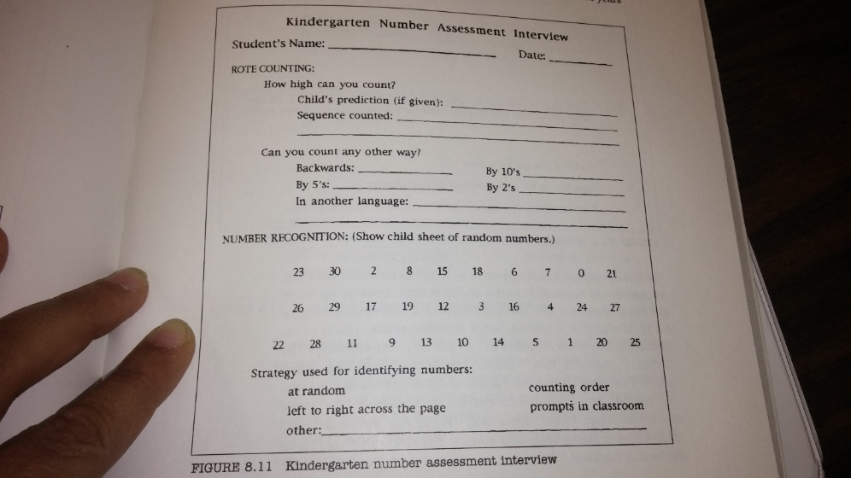
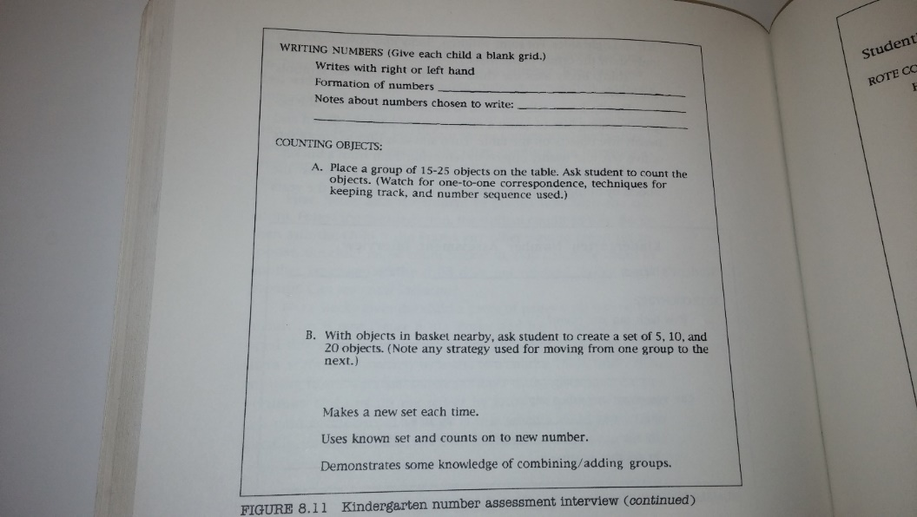
Through the tool, the educator is able to collect the following information:
- How far the student can go, in rote counting
- If the student knows how to count backwards, by 2’s, 5’s or 10’s
- Which numbers the student recognizes in reading, and what are the common reading mistakes
- In what order the student identifies numbers
- What numbers the student can write
- If students have established one-to-one correspondence by checking If this student can count a group of items with 15-25 objects
In the first assessment, Aria predicted that she can count from 1-20; she also thought she could count to 40 when prompted further. She didn’t think that she could count backwards. When asked to read numbers, she read number from 1 to 10. But when she got to the double digits, she confused the unit number to be in place of 10s. For instance, she read 18 as 8, 14 as 40, and so on. While writing, she skipped 2 & 5, and the numbers 3 and 7 were flipped vertically. Thus, the diagnostic assessment led me to conclude that Aria is still developing her number sense, especially while reading. The fact that she mixes units with tens shows that she has not yet been introduced to the number place concept. She is also still experimenting with numbers as she writes 3, 4 and 7 as vertically reflected numbers. I would also follow that with a challenge for Aria to explain why she believes 18 is 8, and why she read 14 as 40. Her explanation would consequently fall in the assessment "as" learning category.
- Pasted below is a copy of her diagnostic assessment, where she was requested to write numbers from 1 to 11.
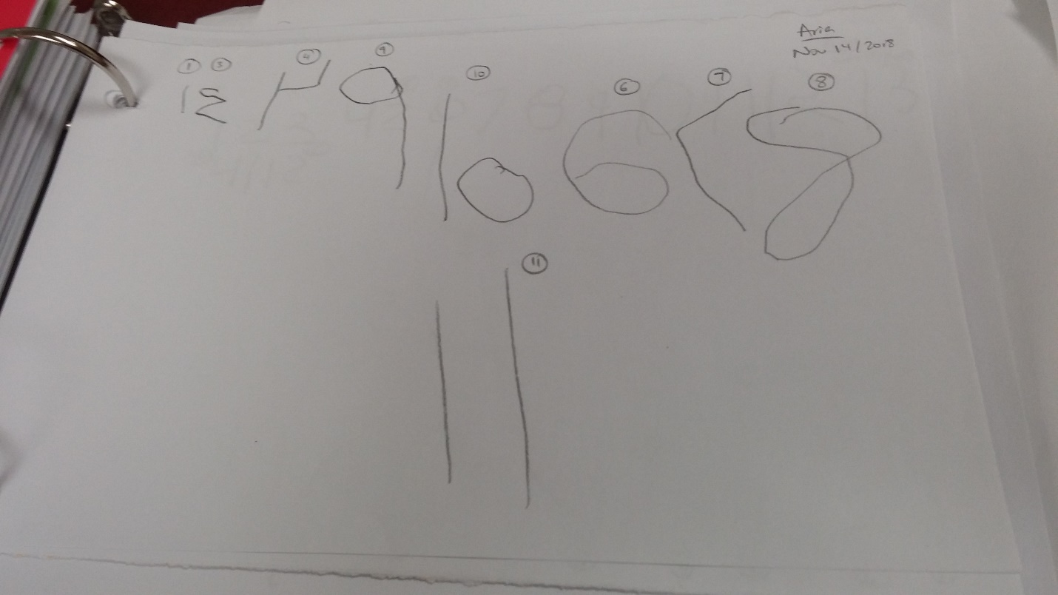
CURRICULUM REFERENCES
15.3 Make use of one-to-one correspondence in counting objects and matching groups of objects
15.4 Demonstrate an understanding of the counting concepts of stable order and of order irrelevance
20.1 Demonstrate an understanding of number relationships for numbers from 1 to 10, through investigation.
20.2 Use, read, and represent whole numbers to 10 in a variety of meaningful contexts
SAMPLE 2: ASSESSMENT FOR LEARNING
LET’S PRETEND TO BE A TEACHER
OBSERVATIONS:
Kylie and Chloe, both JK students, are at the race-to-trace learning centre. When I returned from planning time, I see Kylie teaching numbers to Chloe. They both are practicing their numbers, using the “race to trace addition” sheet. Kylie is demonstrating to Chloe how to write each number, and Chloe is following along. Ravleen, upon observing this pretend play, also wanted to play teacher and actively recruited other children who would pretend to be her students. Chloe repeatedly complemented Kylie and Ravleen for being good teachers, and Kylie complimented Chloe for practicing her numbers.
ANALYSIS/REFLECTION:
I observed peer mentoring and its effectiveness: it is usually difficult to get Chloe’s attention for longer than a few moments, but because a peer (Kylie) was teaching her and because it was part of a game (i.e. Kyle says, “Pretend I’m Mrs. Washburn”), Chloe practiced for a longer time. Kylie and Chloe represented the relationship between a teacher and a student.
I noticed a desire to play with peers, and to get along. I noticed Kylie trying to connect new experiences with what she already knows about the role of a teacher (S.E. 1.5), and her knowledge of numbers. I saw Ravleen hold her students’ hand as she taught them how to write certain numbers. I saw Kylie giving a demonstration to Chloe, thus they were both using non-verbal and verbal communication to communicate their thinking and to solve problems (S.E. 1.6). I saw Chloe demonstrate self-motivation in her approach to learning by persevering and completing tasks (S.E. 2.3). The students in both the teacher and student roles demonstrated the ability to act and talk with peers and adults by expressing and accepting positive messages (S.E. 3.1). By playing pretend together, they also demonstrated an awareness of ways of making and keeping friends (S.E. 3.3). All students also dramatized and represented the everyday experience of being in school (S.E. 5.2)
The next steps I got, as an educator, were to incorporate greater amounts of play even as I try to teach less inquiry-based lessons like handwriting.
EXTENSIONS/CHALLENGES/NEXT STEPS:
Respond – I would respond by asking Chloe, Kylie and Ravleen, “What are the traits of good teachers and good students”?
Challenge – I would challenge Chloe and Kylie to keep practicing for an additional 7 minutes.
Extend – I would extend by encouraging Chloe to learn the names for numbers that fall within the 13-19 range.
CURRICULUM REFERENCES:
(BC/DLMB/PSI): 1.2 listen and respond to others, both verbally and non-verbally, for a variety of purposes and in a variety of contexts
(DLMB/PSI): 1.5 use language (verbal and non-verbal communication) in various contexts to connect new experiences with what they already know
(SRWB/DLMB/PSI): 1.6 use language (verbal and non-verbal communication) to communicate their thinking, to reflect, and to solve problems
(SRWB): 2.3 demonstrate self-motivation, initiative, and confidence in their approach to learning by selecting and completing learning tasks
(BC/SRWB): 3.1 act and talk with peers and adults by expressing and accepting positive messages
(SRWB): 3.3 demonstrate an awareness of ways of making and keeping friends
(BC): 5.2 talk about events and retell, dramatize, or represent stories or experiences that reflect their own heritage and cultural background and the heritage and cultural backgrounds of others
PICTURES:

SAMPLE 3: ASSESSMENT FOR LEARNING
BUILDING WITH BLOCKS
OBSERVATIONS:
The students are playing with blocks during learning centre time. I am especially observing David and Nathan.
David said he built an army truck; he said he needed green blocks for the army truck. David said that he put glue on a cardboard box and that the glue was already dry. David said he is trying to put cardboard at the bottom of the truck so that it doesn’t tip to the back. Later, he got ride of a few blocks and the back end of the truck was no longer tipping over. This was assessment for learning because I was able to assess and identify need for learning how to find balance while building creations out of Lego.
Nathan said that the cat has four legs and a tail. When the tail fell off, Nathan found it humorous. Nathan said he could get rid of a few of the four legs and his cat would still stand. But it did not.
EXTENSIONS/CHALLENGES/NEXT STEPS:
The next steps were to introduce them to the concept of vocabulary and concept of balance and equilibrium.
PICTURES:

SAMPLE 1: ASSESSMENT OF LEARNING
ARIA’S SUMMATIVE ASSESSMENT
In the second assessment, Aria counted until 19, was able to complete one-to-one correspondence until 12 items (as she lost track at 13 or skipped 13), and could read and write until 7. While writing, she continued to write 2, 3, 4, and 7 in vertically flipped forms. The fact that she did not progress significantly from the diagnostic assessment is because we were focusing on numbers till 12 as a class, and she had already established that knowledge base. She did learn to write thirteen as 13 rather than 31, fourteen as 14 rather than 41, and so on, until 19.
Attached below is a copy of her summative, assessment ‘of’ learning sheet where she was requested to write numbers from 1 to 20.
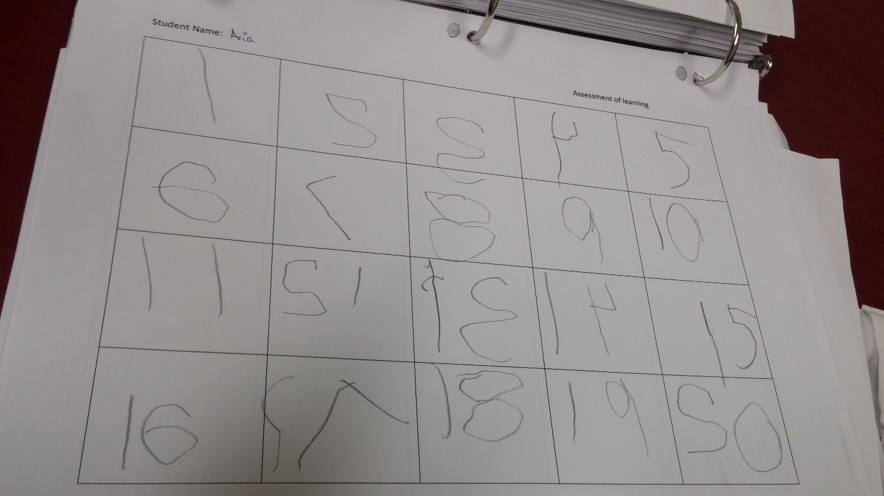
Given that there has not been dramatic improvement in Aria’s performance, and her learning seems to have plateaued, there are a few next steps I will take. I would share Aria’s performance with her parents, so that they can reinforce the introduction of numbers greater than 11. I would also extend Aria’s knowledge by introducing the numbers 11 - 20 in reading. I would also change the learning centres games to better suit Aria’s level of knowledge, as most games right now only go until 12. Thus, I would introduce some differentiation in learning tools and strategies. I would try to find games that introduce the numbers 13 through 20 to Aria in writing and reading. I would also spend some more time working with her on her 2, 3, 4, and 7, so that she can be reminded of the correct way to write these numbers. However, my Associate Teacher informed me that it is normal for children to experiment with writing direction at this age, so I do not find any results as a cause of concern.
Even though we have identified multiple next steps that will continue to inform future teaching during SK, I believe Aria is meeting all the milestones required to join Grade 1 and I would share that with her parents. I can also conclude through the results that she doesn’t seem to have any special needs that would require differentiation in testing. I believe this is the greatest benefit of assessment “of” learning. This evaluation was communicate to the Associate Teacher who would later convey it to the parents.
CURRICULUM REFERENCES
15.3 Make use of one-to-one correspondence in counting objects and matching groups of objects
15.4 Demonstrate an understanding of the counting concepts of stable order and of order irrelevance
20.1 Demonstrate an understanding of number relationships for numbers from 1 to 10, through investigation.
20.2 Use, read, and represent whole numbers to 10 in a variety of meaningful contexts
PICTURE:

SAMPLE 2: ASSESSMENT OF LEARNING
ARIA’S SUMMATIVE ASSESSMENT
OBSERVATION:
It is the last learning circle of the day, which runs from 2.05 pm to 2.30 pm. Mrs. Washburn has assigned activities to different groups and has chosen the group configuration. We have been assigned the Shape n’ Roll activity, which comprises of 4 blank hexagons printed onto a piece of paper. The goal of the game is to fill the four blank hexagons with shapes (triangles, diamond, parallelogram, or a hexagon). The students roll two dice (one standard and one with the shapes drawn on it). The dice that has shapes on it tells the player what to collect and the dice with dots tells the player how many of those shapes to collect.
The three players are Alex M, Thomas and Chloe. After playing a few rounds of the game, Thomas gets distracted and stated building a snow man with a hat (1 yellow hexagon and 1 green triangle). Rocco also built apples (2 green parallelograms and 1 green triangle). Thus, the students were able to create creations using the provided shapes. While playing the games, they demonstrated knowledge of numbers, ability to point and tag and ability to recognize shapes (for instance, a triangle has three corners, a diamond has four corners, etc.) This evaluation was communicated to students through verbal celebration and acknowledgement that they knew their shapes and numbers.
ANALYSIS/REFLECTION:
I noticed the student practice find motor skills as they tried to fit various shapes in the printed hexagons. I noticed them try various ways of placing the same shape into the hexagon, thus decreasing the amount of blank space within the blank hexagon.
Respond: Help Alex M. with point and tag strategy
Challenge: Ask the children how many triangles, diamonds, and parallelograms can fit into one hexagon.
Extend: Introduce fractions through the game, by questioning how much of the hexagon gets covered by each shape.
CURRICULUM REFERENCES:
SRWB 3.2: demonstrated taking turns and waiting for others to roll the dice
PSI 20.4: the kids were able to make snowmen and apples out of the shapes
PICTURES:

SAMPLE 3: ASSESSMENT OF LEARNING
ARIA’S SUMMATIVE ASSESSMENT
OBSERVATION:
Lucas is holding onto a gingerbread man stuffed animal. He is tracing over the eyes, smile and eyebrows and names all the features and says he can draw a gingerbread man. Thus, I noticed tactile and fine motor skills when Lucas was tracing over the facial features. Lucas named the gingerbread man “oven” thus demonstrative memory of and reference to the Gingerbread man book being read during circle time. I conveyed this evaluation to the AT during our planning time conversations.
Lucas wants to hold onto gingerbread man, thus demonstrating a need to learn how to share. I would convey this evaluation by telling both Lucas and Thomas that they need to get better at sharing.
Later, Thomas puts the gingerbread man into a gift box, thus demonstrating a knowledge of measurement and sizes. I congratulated Thomas that he knows how big a box needs to be in order to fit a gingerbread man inside it.
PICTURES:

